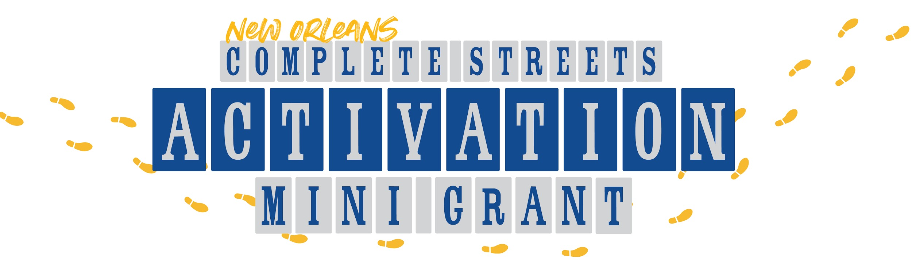

The New Orleans Complete Street Coalition is excited to announce the Complete Streets Activation Program. This new mini-grant program will fund civic groups, community leaders and individuals to develop an event or project that builds grassroots support for safe and accessible streets and highlights the benefits of the City's expanded low-stress bikeway network.

NOCSC is a coalition of over two dozen organizations who believe in building streets for all people who use them, while enhancing the health, equity, sustainability, prosperity, and quality-of-life for the people of New Orleans. The CS Activation Mini-Grant program aims to empower residents to engage their peers and celebrate the coming complete streets improvements.

We are looking for civic and community leaders, artists/creatives, business leaders, and individuals based in New Orleans to lead an activity, host an event, or design a project that will help inform their community about the benefits of complete streets and the low-stress bikeway network. Eligible activities include (but are not limited to): community bike rides, walking tours, temporary art installations, essay/photo contests, and community events.

Funding:
The grant size will range from $500-$2000, with an average award of $1,000. The Complete Streets Coalition aims to award between 10-20 grant proposals, varying in size and scope. Our goal is to empower our community to engage in this work; we welcome all costs associated with delivering a successful project. While no preference will be given to smaller or larger requests, the selection committee does reserve the right to award amended budgets.

Timeline:
The CS Activation Mini-Grant will accept two cohorts of applicants. The first cohort will be accepted on a rolling basis until July 1st, 2020. These applicants will be notified by August 1st at the latest, and will be expected to complete their project by October 31st. Round two applications will be due September 1st, and will be notified about their selection by October 1st. Selected recipients will be expected to complete their projects between October 1st and December 31st.

Submission:
You can apply online at nolacompletestrees.org/activation-mini-grant or by emailing a scanned application to Robert Henig Bell at rob@bikeeasy.org with the subject Activation Mini-Grant.

NEW ORLEANS COMPLETE STREET ACTIVATION MINI GRANT APPLICATION

Name of Lead Applicant(s):________________________________________________

Lead’s Email: ___________________________ Phone Number: _________________

Name of Affiliated Organization:____________________________________________

Address:______________________________________________________________

Website/social media (optional):____________________________________________

Project Idea:

Please briefly describe your project idea:

How will your project build awareness and promote education around complete streets and/or the City’s low-stress bikeway network?

Please list the names of the key individual(s) in this project, their role, and relevant skills

Please list relevant dates and milestones for your project

Where will your project take place? Please list the neighborhood and address information.

How do you plan to advertise and promote your project? Are there any specific community affiliations that you have that you would use for outreach?

Impact:

Many people use the road, who would your project specifically target? (check all that apply)

- Walkers
- Car Drivers
- Commercial Drivers
- Bikers
- Public Transit Users
- Senior Citizens
- Youth
- Low-income populations
- Minority populations
- Women/non-binary-focused
- Those with physical or visual impairments
- Other: ____________________________

Who would your project engage? How many people do you expect to participate?

What do you expect participants to take away from your project?

BUDGET:

Please include a budget for your project. You can use the template provided below.

Item | Unit Cost | Quantity | Total Cost
Ex: Sidewalk Paint | $10 | 5 Gallons | $50.00
 | $ |  | $
 | $ |  | $
 | $ |  | $
 | $ |  | $
 | $ |  | $
 | $ |  | $
 | $ |  | $
Total Requested Amount: |  |  | $

